Local Development Finance Authority (LDFA)
MEMBERS
Luke Hackney, Chair
James Tischler, Vice-Chair
Ben Bakken, Treasurer
Brian McGrain, Secretary
Derrell Slaughter
Jessy Gregg
Thomas Fehrenbach
David Washburn
Charles Hasemann

MEDC LiaisoN
LeTasha Peebles

LEAP STAFF
Joe Carr
Anum Mughal
(517) 702-3387
Local Development
Finance Authority (LDFA)
City of Lansing
City of East Lansing
Ingham County

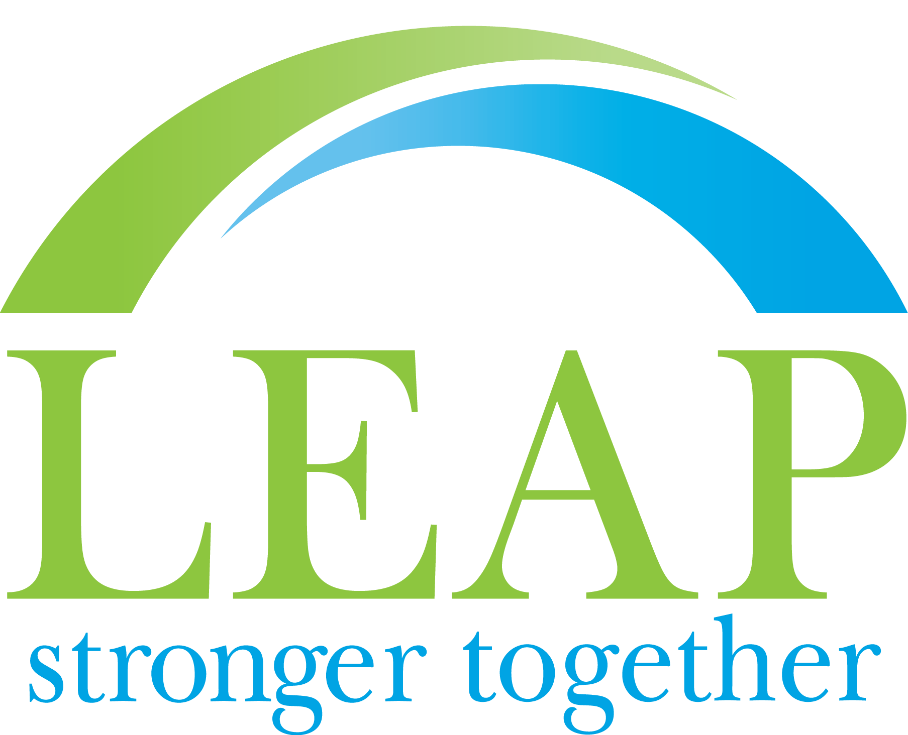
www.purelansing.com

Board Meeting

Location: Lansing Economic Area Partnership (LEAP)
Date: Wednesday, March 17th, 2021
Time: 3:00 p.m.

AGENDA

- Call to Order & Roll Call Hackney
- Project vs audited reconciliation Bakken
- Audit (Action) Carr

- Approval of LDFA Meeting Minutes (Action) All

- Approval of LDFA Draft Financials (Action) All

- TIF Renewal updates/discussion Carr/Dempsey

- BAF updates Carr

- TIC updates Smith/Allum

- Other Business All
- Public Comment All

- Adjournment Hackney

