Local Development Finance Authority (LDFA)
MEMBERS
Luke Hackney, Chair
James Tischler, Vice-Chair
Ben Bakken, Treasurer
Brian McGrain, Secretary
Derrell Slaughter
Jessy Gregg
Thomas Fehrenbach
David Washburn
Charles Hasemann

MEDC LiaisoN
LeTasha Peebles

LEAP STAFF
Joe Carr
Anum Mughal
(517) 702-3387
Local Development
Finance Authority (LDFA)
City of Lansing
City of East Lansing
Ingham County

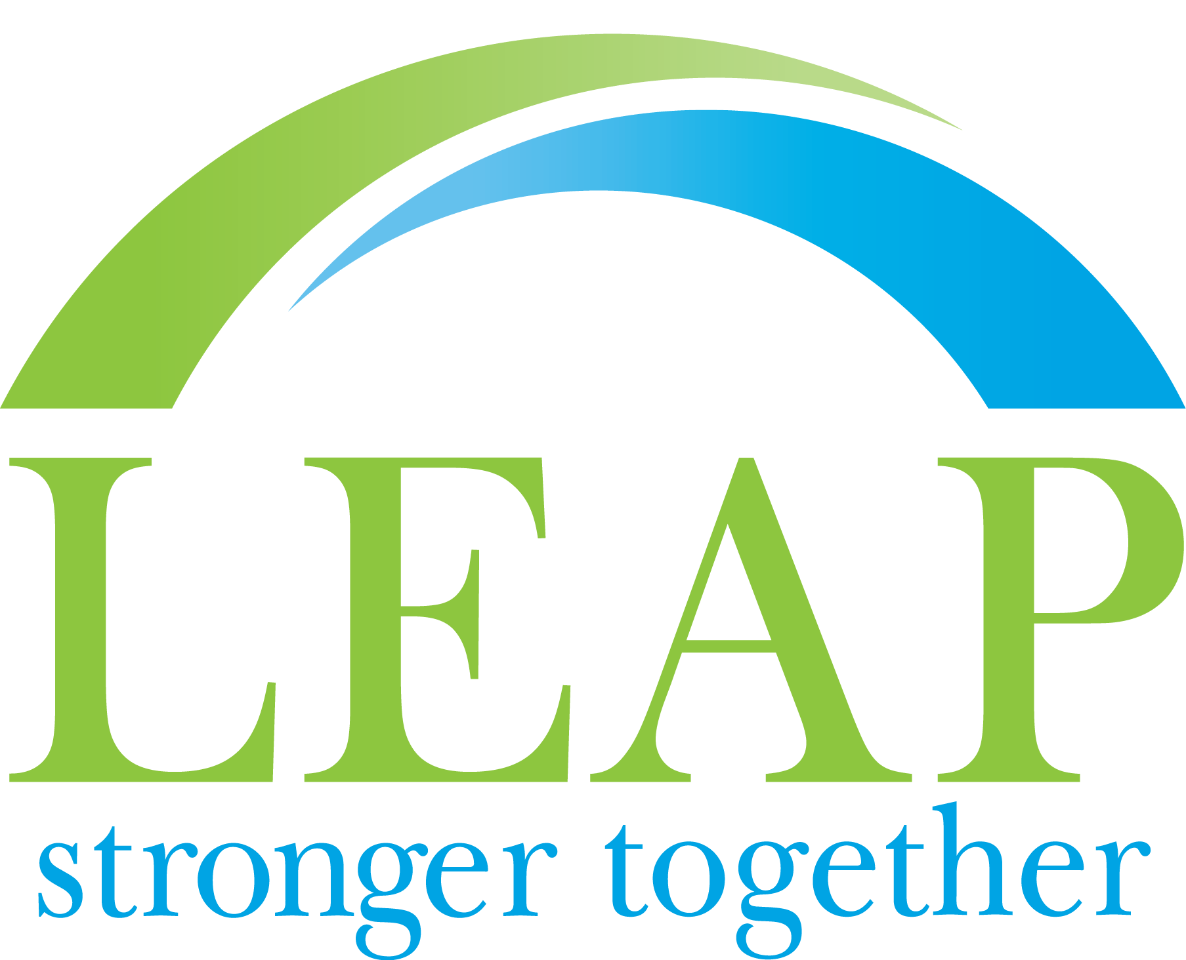
www.purelansing.com

Board Meeting

Date: Friday, June 25, 2021
Time: 10:30 a.m.

THIS MEETING WILL BE HELD ELECTRONICALLY*
Access the meeting via: https://us02web.zoom.us/j/86360506052
Meeting ID: 863 6050 6052
Dial In: +1 312 626 6799
*See attached Public Participation Notes

AGENDA

- Call to Order & Roll Call Hackney
- Approval of LDFA Meeting Minutes (Action) All
- LEAP 2020/2021 Contract Results/Outcomes Carr
  - Past years LEAP/SZ history of services
- BAF 2020/2021 Review/Outcomes Carr
- Sub-Committee Organizational update All
- Adoption of FYE 2022 budget (Action) All
- LEAP administrative contract
(Action) All
- SmartZone contract benchmarking
statewide Carr
- TIC updates Smith/Allum

- Other Business All
- Public Comment All

- Adjournment Hackney

