Local Development Finance Authority (LDFA)
MEMBERS
Luke Hackney, Chair
James Tischler, Vice-Chair
Ben Bakken, Treasurer
Brian McGrain, Secretary
Jessy Gregg
Thomas Fehrenbach
Derrell Slaughter
Dave Washburn
Charles Hasemann

MEDC LiaisoN
LeTasha Peebles

LEAP STAFF
Joe Carr
Anum Mughal
(517) 702-3387
Local Development
Finance Authority (LDFA)

City of Lansing
City of East Lansing
Ingham County

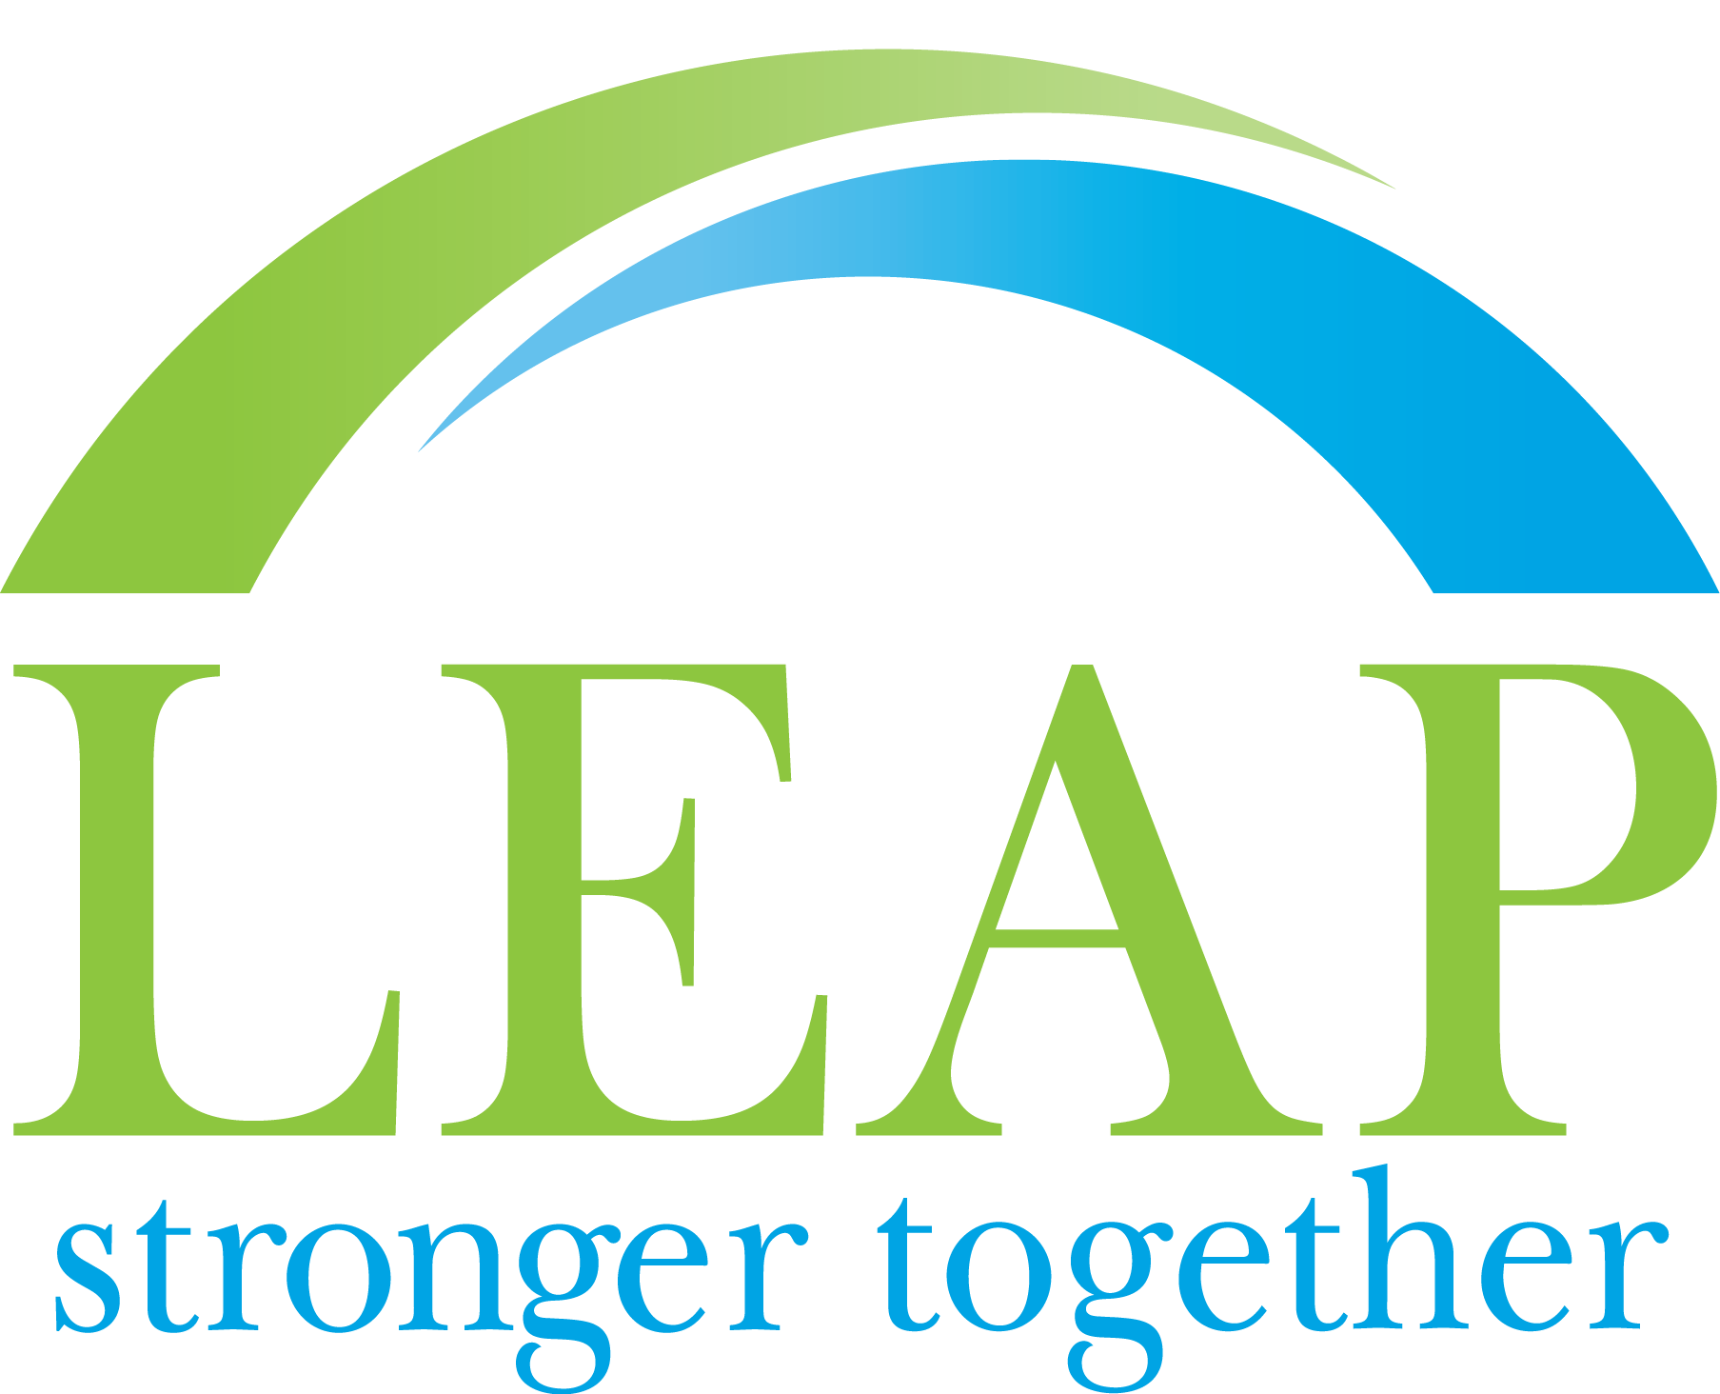
www.purelansing.com

Informational Meeting 2

Location: Lansing Economic Area Partnership (LEAP) via Zoom
1000 S Washington Ave, Ste. 201, Lansing, MI 48910
Date: Wednesday, June 30, 2021
Time: 2:00 p.m.

AGENDA

- Call to Order & Roll Call

- Overview of Smartzone/LDFA

- Public Comment
- Adjournment

