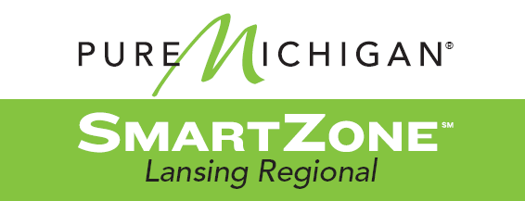
LANSING REGIONAL SMARTZONE

1000 S. WASHINGTON AVENUE, SUITE #201
LANSING MI 48910 | PHONE: (517) 702-3387

PUBLIC MEETING NOTICE

THERE WILL BE a MEETING OF THE JOINT LOCAL DEVELOPMENT FINANCE AUTHORITY (LDFA) ON:

Tuesday, October 27, 2021 AT 11:00 AM

THIS MEETING WILL BE HELD IN-PERSON
LEAP
2nd Floor conference room
1000 S Washington Ave, #201
East Lansing, MI 48823

CONTACT:
Please direct any questions regarding participation in this meeting to Joe Carr at joe@purelansing.com or (517) 702-3387.

Persons with Disabilities:
Individuals with disabilities requiring auxiliary aids or services in order to attend should notify Joe Carr at joe@purelansing.com or (517) 702-3387 within a reasonable time in advance of the meeting.

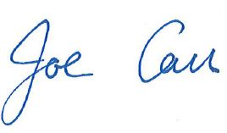

_
Joe Carr, Vice President, Entrepreneurship & Innovation Team Lansing Economic Area Partnership (LEAP)

